Software Requirements Specification
for
TRAFFIC MANAGEMENT
USING
DEEP LEARNING
Guide
Mr. J. S. Pujari Sir

Prepared by,
Chintamani Naik
Yash Mudgal
Nikhil Patil
Vivek Patil
Sandeep Pandita

Table of Contents
Table of Contents 1
1. Introduction 1
1.1 Purpose 2
1.2 Document Conventions 2
1.3 Intended Audience and Reading Suggestions 3
1.4 Product Scope 3
1.5 References 3
2. Overall Description 4
2.1 Product Perspective 4
2.2 Product Functions 5
2.3 User Classes and Characteristics 6
2.4 Operating Environment 6
2.5 Design and Implementation Constraints 7
2.6 User Documentation 7
2.7 Assumptions and Dependencies 7
3. External Interface Requirements 7
3.1 User Interfaces 7
3.2 Hardware Interfaces 7
3.3 Software Interfaces 8
3.4 Communications Interfaces 8
4. System Features 8
4.1 System Application 8
4.2 Admin Application 4
5. Other Nonfunctional Requirements 9
5.1 Performance Requirements 9
5.2 Safety Requirements 9
5.3 Security Requirements 9
5.4 Software Quality Attributes 9
6. Other Requirements 10

Introduction
This section gives a scope description and overview of everything included in this SRS document. Also, the purpose for this document is described and a list of abbreviations and definitions is provided. The Section also gives an insight of suggested reading audience or technical knowhow required for moving ahead with the document as well as any suggested reading or external reading is required before proceeding with the document.

Purpose
The purpose of this document is to provide a brief overview of Traffic Management Using DL, An application which makes automatic allocation of time for traffic signal according to different conditions of traffic. The different software requirements of Traffic Management Using DL are described in the Document which will outline all the technical aspects regarding development of Traffic Management Using DL. It will illustrate the purpose and complete declaration for the development of system. It will also explain system constraints, interface and interactions with other external applications. This document is primarily intended to be proposed to a customer for its approval and a reference for developing the first version of the system for the development team. The software requirement specification in this document is a all time reference for the basic requirements for proceeding with the development.

Document Conventions
The following conventions are used through the document and should be understood accordingly. The table below shows a list of all the conventions used in the document given below.

DL | Deep Learning
CNN | Convolutional Neural Network
RCNN | Region Based CNN
CCTV | Close Circuit Television

Intended Audience and Reading Suggestions
This project is a concept of dynamic traffic signal proposed as a solution to the conventional problem of fixed traffic signal regulations and the problems faced by its manual behavior. The Project has been implemented under the guidance of our professors and is used and implemented using the data set put forward by students. Thus the application developed is for college project purpose.

Product Scope
The project deals with the development of desktop, stand-alone application for the purpose of Traffic Management Using DL. The application is supposed to change the way the manual signal assignment is carried out for different situations. The project can help government to achieve increase in efficiency of signal allocation scheme as defined and used till date by the traffic regulations authorities. We focus on the detection and recognition of vehicles in a video stream. For this reason, we have used the convolutional neural network technique (CNN) and a dataset that contains images to enable recognition and classification of vehicles. The input video stream is CCTV at signal which provides live images. The video is converted into frames for processing and further calculations are carried out accordingly and results are sent to traffic signal timer which updates the different types of signals for different lanes.

References
- http://www.ijcstjournal.org/volume-6/issue-3/IJCST-V6I3P5.pdf
- http://www.ijlemr.com/papers/volume4-issue2/4-IJLEMR-44009.pdf
- http://www.tensorflow.org
- https://docs.opencv.org/master/d6/d00/tutorial_py_root.html

Overall Description

Product Perspective
Vehicle detection allows the use of various applications of artificial intelligence system for several purposes, especially: intelligent transportation, automatic monitoring, autonomous driving, and driver safety guarantee. In this work, we focus on the detection and recognition of vehicles in a video stream. For this reason, we have used the convolutional neural network technique (CNN) and a dataset that contains images to enable recognition and classification of vehicles. Convolutional neural network efficiency depends to a large extent on the quality of the training data set; the network will produce good results only if the training data used contain sufficient important characteristics so that they can produce new predictions.
The proposed solution will have an object detection model which can identify different types of vehicles built in tensorflow. To develop an object detection model we need to give training images and apply preprocessing then pass the dataset to CNN algorithm. The model will be used for identifying different vehicles. The proposed project is supposed to work on as a desktop application or standalone as far as the project is concerned.

Product Functions
The major functions of the product to be developed are shown in the block diagram below.

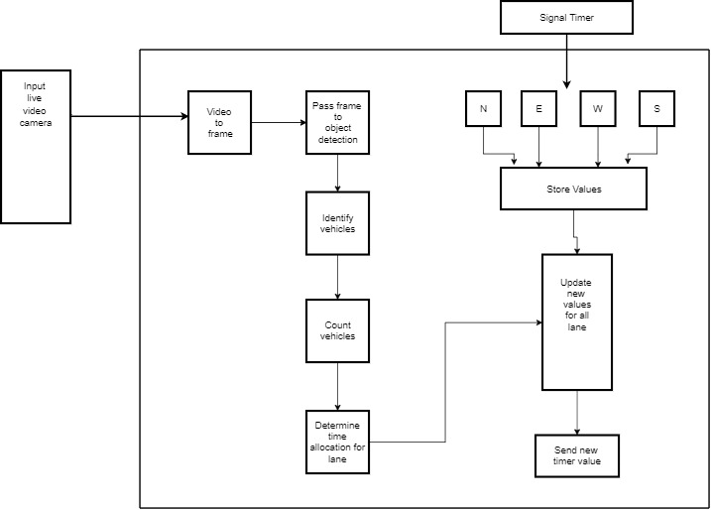

Figure: Block diagram of application
Web Services
Web Services

User Classes and Characteristics
User of the system in this case is the field officer who should be able to login using the ID provided. The ID is unique to the field officer who will be monitoring the traffic signal. The field officer can login to application and should be able to perform the following operations

- Login into the system against his ID to keep at track of his login status
  - Select input CCTV footage
  - Observe and monitor vehicles detected
  - Monitor traffic signal timers before any processing
  - Get results for traffic analysis and signal timer

The Government officials should be able to perform the following functions.
- Login using a single window on the server
  - Check the details of the current traffic
  - Check if proper lane assignment is carried out
  - Generate reports
  - Compare reports

Operating Environment
The following operating environment is required for the system to operate.
- A system with following specifications
- 8 GB RAM(16 GB recommended)
- Core i3/i5 processor
- At least 500 MB of free disk Space
- Operating system Windows/UBUNTU

Design and Implementation Constraints
The following implementation constraints are expected through the development as well as post development.

- We utilized the pre-trained models of Cars and Trucks, which were trained by using Tenser flow.
- The availability of input video to update the collected data.
- The computer which is executing the application has met requirements specified.

User Documentation
- Project report with test data
- Operating instructions to operate the application

Assumptions and Dependencies
The following factors are assumed before the starting of the project

- The CCTV is placed at location which covers maximum portion of a lane
- The input video stream is consistent and not distorted
- The traffic signal can be adjusted according to the need of situation

External Interface Requirements

User Interfaces
- Desktop Application User Interface in anaconda spyder

Hardware Interfaces
The proposed project is supposed to work on any Desktop Application as far as the project is concerned. The admin panel of the program can be accessed by system having configuration specified in operating environment section of this document. There is no such hardware requirement for the Desktop application part.

Software Interfaces
Following Software requirements are used for the development of Traffic Management Using DL
OpenCV | It mainly focuses on image processing, video capture and analysis including features like object detection.
Tenserflow | It is an open source artificial intelligence library, using data flow graphs to build models.
Anaconda Spyder | IDE For python application development
Anaconda | For compiling python files as we will be using python native to desktop application.

Communications Interfaces
The project supports all configurations of devices fulfilling minimum requirements specified in operating environment section. The project supports windows operating system as well as Linux. We will be using web camera to communicate with the Desktop application.

System Features
This section deals with the feature that will be provided by the end product. The features of the product in detail are discussed here.

Traffic Management Using Deep Learning
- Provides an software interface for officers to login into the system for monitoring and control of traffic
- Calculation of signal time assignment
- Automatic Update of data to the traffic signal
- Report generation

Other Nonfunctional Requirements

Performance Requirements
- The application should not crash under any circumstances. Care must be taken to avoid breaks in input stream.
- The application should be compatible across various operating versions of Windows, Linux
- Easy login and logout sessions for officers
- Application should process images in faster manner and in low amount of time

Safety Requirements
The make sure the data is not lost due to hard disk crashes or any other failures regular backup of collected data should be maintained. This requires regular backups of the data to be made every day to prevent any data loss of collected price.

Security Requirements
The password should be encrypted to prevent any data hacks so that incorrect assignment or sensitive data won’t be compromised. Additionally the timer values calculated needs to be accurate.

Software Quality Attributes
- CORRECTNESS: The specific details entered and calculated should be correct.
- MAINTAINABILITY: Should be easily updated with minimum efforts.
- USABILITY: The application should be easy to use and automate most of the tasks in traffic management.

Other Requirements
For training the model a computer with following specification is required

  - For Tensorflow-CPU
    - Tensorflow cpu library 1.14.0 version
    - Pentium Dual-Core or above CPU's
    - RAM 4 GB minimum
    - Disk Space 1 GB minimum

  - For Tensorflow-GPU
    - Tensorflow library 1.14.0 version
    - Pentium Dual-Core or above
    - RAM 4 GB minimum
    - Disk Space 1 GB minimum
    - NVIDIA Graphics Driver with Compute Capability over 3.5
    - NVIDIA CUDA 10.0 Toolkit
    - NVIDIA cuDNN SDK

